11/24/2024

**Module 4.1 Assignment**

**Shari Storlie**

**Student ID: 2176702**

**CS-340**

Step 1: Upload the Austin Animal Center (AAC) Outcomes data set into MongoDB by **importing a CSV file using the appropriate MongoDB import tool**.

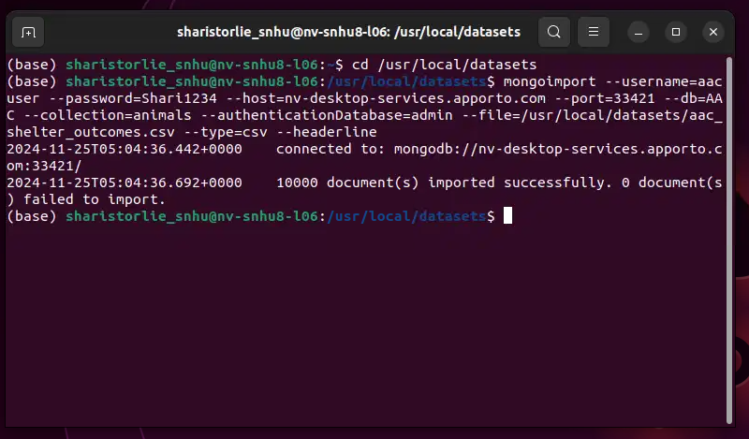

Step 2: Develop a Python module in a PY file using object-oriented programming methodology to enable **create** and **read** functionality for the database.

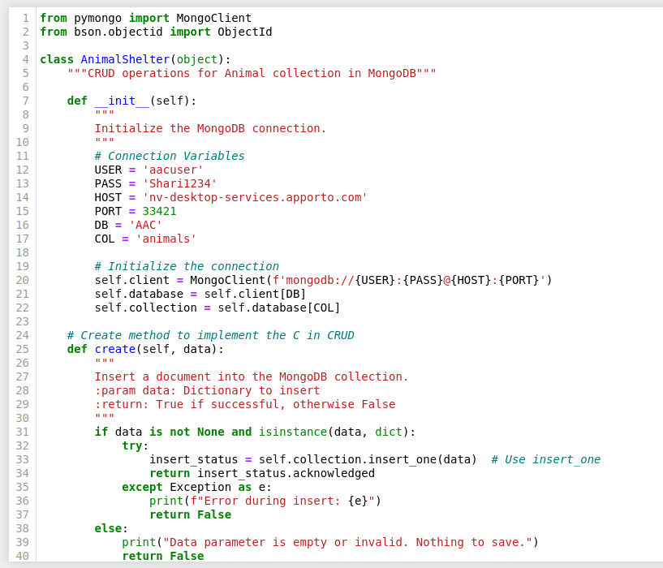

Step 3: **a Python testing script in Jupyter Notebooks that imports your CRUD Python module to call and test the create and read instances of CRUD functionality**.

